**L’Epée 1839 Creative Art Residency**

**Presenting Unique creations highlighting the manufacture’s métiers and inspired artistic partnerships**

L’Epée 1839 draws inspiration from worlds as diverse as contemporary design, and various art forms. Today our manufacture unveils a new series of unique creations, highlighting its craftsmanship and daring creativity. Iconic pieces from its Creative Art line are reimagined through an artistic lens, each transformed into a one-of-a-kind work of art. Every Unique piece showcases either the manufacture’s full in-house expertise or its collaborations with talented artists. The result is a collection of kinetic sculptures that transcend artistic boundaries, blending craft and creativity into singular masterpieces — each with its own distinct personality, and feel, celebrating artistry and individuality.

Behind every creation is a team of designers, engineers, mechanics, and master watchmakers whose passion drive the manufacture forward. From development to the final assembly, each clock passes through the hands of these artisans, who combine centuries-old know-how with bold innovation. Their expertise ensures that every detail — from the beating heart of the movement to the gleaming surface finish — reflects the soul of true craftsmanship.

The manufacture has been a place of creative partnerships, embracing collaborations and exploring new territories, where in-house expertise and external artistry come together to enrich each creative piece. Driven by this spirit of co-creation and innovation, L’Epée 1839 continues to push the boundaries of horology, offering collectors pieces that are timeless, daring, and fused with artistic expression.

Renowned for its technical mastery, extra-long power reserves, impeccable finishing, playfulness and unexpected touches of humor, L’Epée 1839 has earned a reputation for turning clocks into extraordinary kinetic mechanical sculptures.

For more than 185 years, L’Epée 1839 has cultivated the art of high-end mechanical clockmaking. Today, it remains the only Swiss manufacture fully dedicated to mechanical clocks, preserving traditional savoir-faire while embracing innovation under one roof.

**La Regatta Wenge edition**

***Resident Artists : Adeco– craftsmen workshop Milagros Rodrigues – designer***

For this special edition, L’Epée 1839 dresses *La Regatta* in finely crafted wooden shells, created by the artisans of the Adeco workshop—a refined tribute to the noble art of boatbuilding. Like the sleek rowing shells designed to glide effortlessly across the water, these natural contours embody tradition, balance, and the timeless elegance of sculling.

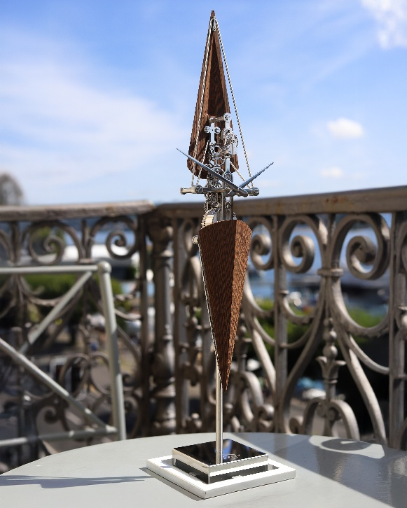

**About Regatta**

L’Epée harnesses and pays homage to the grace of sculling with La Regatta, a sleek vertical clock invoking the shape of the long thin scull, with both the power (8-day power reserve) and precision of the most elegant of watch sports. Our modern lives are often busy and, at times, even chaotic, La Regatta invokes a sense of peace and calm.  
  
The long blade-like hands of La Regatta echo the sleek shapes of the elongated triangle shells and make for effortless reading of the time. At 9:15, the hands are positioned like the blades of a scull, which do not pull through the water but anchor in the water to propel the craft. The visible isochronous oscillating balance wheel governs the beat, just like the coxswain of a quad scull.  
Its gracefully elegant, tall and narrow 520 mm (20 inches) height, is supported by a substantial base, ensuring a low centre of gravity and maximum stability.   
Sculling requires perfect balance, both in the symmetry of position and delivery of power. La Regatta mirrors that symmetry with its mainspring balance in line and in harmony with its escapement, ensuring power is delivered smoothly and precisely.  
The full gear train of La Regatta’s movement is arranged in a single line, evoking both the backbone of the rowers that transmits power from their arms to the craft and the single line of multiple scullers in a quadruple boat. And La Regatta’s balanced aesthetics are not simply one-dimensional, the mainspring barrel is on the opposite side of the movement of the escapement, distributing weight and power evenly throughout its form just as sculling does.

The powerful 8-day movement of La Regatta is wound on the back of the movement by a key, which also sets the time.

**About craftsmen workshop Adeco :**

With over a century of know-how, Adeco has built a reputation for excellence in both the creation and restoration of fine woodwork, including projects for Historic Monuments. Its team of passionate craftsmen combines ancestral techniques with modern innovations, ensuring precision, respect for materials, and lasting quality. From design to production, Adeco passes down a culture of high standards and attention to detail, keeping alive the heritage of past masters while shaping contemporary carpentry. This expertise has been recognized with numerous awards, including the national qualification in advanced carpentry.

**About Milagros Rodríguez:**

La Regatta was designed in partnership with Milagros Rodríguez, a talented Peruvian artist based in Switzerland. Milagros first trained as an architect until a passion for Latin American arts and crafts led her to a career in design. It was while studying for her Master’s Degree and at the prestigious École Cantonale d'Art de Lausanne that she met L’Epée CEO Arnaud Nicolas who was considering developing a new clock based on a nautical theme. La Regatta is the fruit of their collaboration.

**Technical specifications**

The Fluorescent Regatta

Dimensions & Weight: 518 mm high, base 120 mm square - 1.75 kg

Functions : Hours and minutes

Movement : L’Epée 1839 in-house mechanical movement, 8-day power reserve

Materials & Finishing : Palladium-plated brass, Wenge wood